Lab Report No 04

**Database Development using MySQL**

**_____________________**

**403L-Database Management Systems**

**Department of Computer System Engineering**

**University of Engineering and Technology Peshawar**

Submitted to: **Engr. Sumayyea Salahuddin**

Submitted by: **Muhammad Saad**

Reg ID: **21PWCSE1997**

**DCSE, Batch 23, Section “B”**



Student Signature: ____________

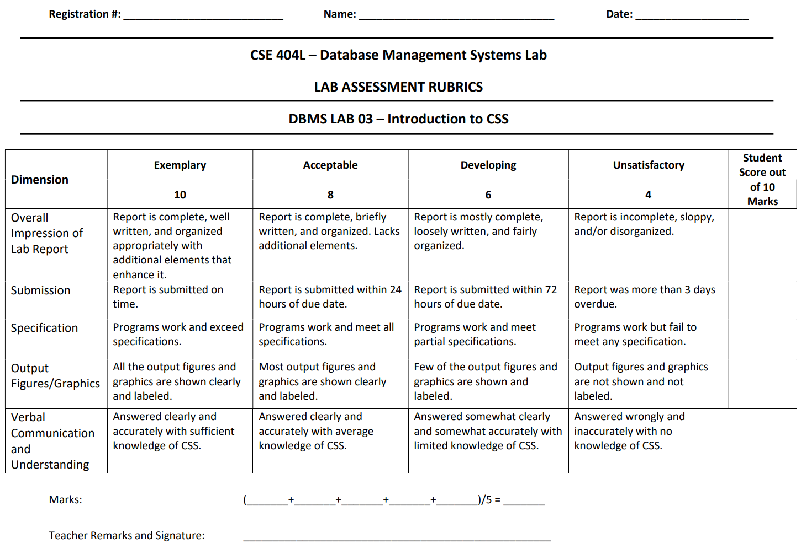 21pwcse1992 Muhammad Saad 3/15/2024

**Lab 4: Database Development using MySQL**

**Lab # 04: Database Development using MySQL**

**Objective:**

This lab aims at the understanding of:

* The concept of Dynamic HTML
* Cascaded Style Sheets (CSS)
* Various attributes of CSS such as font, color, background, text, border, margin, and list
* User-Defined Selectors including Class and ID
* Span and Div Tags
* External Style Sheets and their benefits

**Tasks 4.1**

**Q1: What is DDL, DML, TCL, and DCL? Explain in your own words. Also, list few commands in each language.**

**A:**

**DDL (Data Definition Language):** DDL is used to define the structure and organization of a database, including creating, modifying, and deleting database objects such as tables, indexes, and relationships.

Examples of DDL commands:

* CREATE TABLE
* ALTER TABLE
* DROP TABLE
* CREATE INDEX
* CREATE VIEW

**DML (Data Manipulation Language):** DML is used to manage the data stored in a database, including inserting, updating, and deleting data.

Examples of DML commands:

* INSERT INTO
* UPDATE
* DELETE
* SELECT (also used in querying, but can be used to manipulate data)

**TCL (Transaction Control Language):** TCL is used to manage database transactions, including committing, rolling back, and saving changes.

Examples of TCL commands:

* COMMIT
* ROLLBACK
* SAVEPOINT
* RELEASE SAVEPOINT

**DCL (Data Control Language):** DCL is used to control access to a database, including creating and managing user accounts, permissions, and access rights.

Examples of DCL commands:

* GRANT
* REVOKE
* CREATE USER
* ALTER USER
* DROP USER

**Tasks 4.2**

**Q: What is difference between SQL and MySQL? Why is MySQL used? What are its features?**

Difference between SQL and MySQL

SQL: a programming language for relational databases  
MySQL: a specific relational database management system (RDBMS) that uses SQL

Why is MySQL used?

* Open-source and free
* Cross-platform compatible
* High performance and scalability
* Easy to learn and use

Features of MySQL

* Supports standard SQL queries
* Table management and indexing
* Various data types
* Robust security and access control
* Scalable and high-performance

___________________________

**Tasks 4.3**

**Q: What is database engine? What purpose does it serve? How many types of engines are supported by MySQL? Which database engine is most commonly used and why?**

**A: Database Engine:** A database engine is the core software that handles data in a database system, like storing, retrieving, and managing it. Imagine it as the engine in a car, making everything run.

* **MySQL**, a popular database system, offers different options for this engine, like **InnoDB** (reliable and good for business use) and **MyISAM** (faster for reads but less powerful).
* **InnoDB** is the most popular choice because it offers features like transactions and data protection, important for most users.

__________________________

**Tasks 4.4**

**Q: Specify at least fifteen (15) or more different data types supported by MySQL. Provide the description with at least one example.**

**A:** MySQL offers a wide variety of data types to store different kinds of information. Here are over fifteen data types you can use:

**Numeric**

* **INTEGER (INT):** Stores whole numbers, typically in the range of -2,147,483,648 to 2,147,483,647. (Example: Employee ID: 12345)
* **SMALLINT:** Stores smaller whole numbers, often used to save space. (Example: Month of birth: 8)
* **TINYINT:** Even smaller whole numbers, perfect for flags or small counters. (Example: IsAdmin (Yes: 1, No: 0))
* **MEDIUMINT:** Stores whole numbers in a medium range. (Example: Order quantity: 250)
* **BIGINT:** Stores very large whole numbers. (Example: Product code: 987654321012345)
* **DECIMAL/NUMERIC:** Stores fixed-point numbers with a specific number of decimal places for precise calculations. (Example: Price: 15.99)
* **FLOAT/DOUBLE:** Stores approximate numeric values with a large range. (Example: Scientific data: 3.14159)
* **BIT:** Stores single binary digits (0 or 1). (Example: IsActive (Active: 1, Inactive: 0))

**Date and Time**

* **DATE:** Stores just the year, month, and day. (Example: Order date: 2024-04-20)
* **TIME:** Stores only the time portion (hours, minutes, seconds). (Example: Flight departure time: 14:30:00)
* **DATETIME:** Stores both date and time information. (Example: Login timestamp: 2024-04-21 22:42:00)
* **TIMESTAMP:** Similar to DATETIME but can update automatically. (Example: Last modified time: 2024-04-21 22:42:00)

**String**

* **CHAR(n):** Stores fixed-length character strings, uses same space regardless of data size. (Example: Customer name (limited to 25 characters): John Smith)
* **VARCHAR(n):** Stores variable-length character strings, only uses space for actual data. (Example: Product description: This is a great product...)
* **TEXT/BLOB:** Stores large text or binary data. (Example: Product manual (long text document), Product image (binary data))

**Others**

* **ENUM:** Stores a value from a predefined set of options. (Example: Order status (Pending, Processing, Shipped))
* **SET:** Similar to ENUM but allows multiple selections from the defined options. (Example: Product category (Clothing, Electronics, Both))
* **JSON:** Stores data in JavaScript Object Notation (JSON) format for complex data structures. (Example: User preferences: {"color": "blue", "font": "Arial"})

_______________________________________

**Tasks 4.5**

**Q: Consider the Relational Schema given in Figure 4.3 and its tables given in Figure 4.4. Write SQL commands to create all the tables. Take the appropriate attribute type and length from the data provided. (Note: Use the following hierarchy for table creation: 1) Type, Tournament and Team, 2) Member, and 3) Entry).**

**Ans:**

**Tasks 4.6**

**Q: Using insert command, populate all the records in member, type, entry, team, and tournament tables according to Figure 4.4a and Figure 4.4b.**

**Ans:**

**Tasks 4.7**

**Q: Write the query for the following:**

**a) List the first name, last name, and phone numbers of all the members.**

**b) List complete information of all the male members.**

**c) List complete information of all the members who joined after 01-01-2013.**

**d) List name of all the members who belonged to Team A.**

**e) List complete information of all the senior members.**

**f) List complete information of all the members in order of LastName.**

**g) Retrieve the number of records in Member table.**

**h) Provide the first name and last name of the two coaches.**

**i) Find the amount of fee provided by each member by mentioning member first name, last name, and fee. (Hint: use the member and type tables.)**

**j) Delete the record from Entry table where Member=415 and TourID=40. k) Update the Fee of Associate in Type table from 60 to 80.**

**Ans:**

**Tasks 1.6**

**Q: MySQL supports various built-in functions belonging to various categories such as numeric functions, string functions, and date & time functions. Write MySQL commands for following numeric functions: ceiling, cos, degrees, log10, mod, radians, round, sqrt, and truncate. Next write MySQL commands for following string functions: concat, upper, lower, repeat, reverse, regexp, replace, length, ltrim, and rtrim. Finally write MySQL commands for following date & time functions: curdate, week, date_from, quarter, now, sysdate, and date_format.**

**Ans:**

**Tasks 1.6**

**Q: MySQL uses various operators such as Comparison (<, >, <=, >=, ==, and !=), Boolean (AND, OR, and NOT), and Special Operators (Between, Like, IN, Is Null, and Distinct). Give examples of these for Golf database created in this lab.**

**Ans:**

**Tasks 1.6**

**Q: lter is an important command of MySQL. It is used to alter variety of things associated with a database. It can alter the overall characteristics of database, metadata, view, function, procedure, event, and user. Alter table is used specifically for altering the table metadata. Write MySql statements involving alter table for following:**

**a) Add new column DOB to store member date of birth. Its type is date and can be null.**

**b) Now change the name of newly added column from DOB to M_DOB with date as data**

**type and not null.**

**c) Now drop the M_DOB column from member table.**

**d) Next drop the primary key TourID from tournament table.**

**e) Now add new primary key TourID into tournament table.**

**f) Next drop the foreign key Coach from member table.**

**g) Now add the new foreign key Coach from member table.**.

**Ans:**